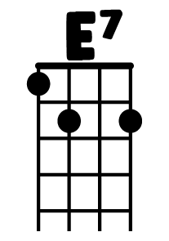

# I Should have Known Better

C G C G C G C G

CGC G C G C G

I…….Should have known better with a girl like you

C G Am F

That I would love everything that you do And I do.

G C G C

Hey! Hey! Hey!.... and I do

G CGC G C G C G

Woa oh woa oh I.......Never realised what a kiss could be

C G Am

This could only happen to me.

F E7

Can't you see? Can't you see?

Am  **F C E7**

That when I tell you that I love you, Oh........

Am F C C7

You’re gonna say you love me too..oo.oo..oo..oo..Oh...

F G C Am

And when I ask you to be mi...i..i..ine

F G C G C G

You’re gonna say you love me too…

G CGCG C G C G

So oh, I……never realized a lot of things before

C G Am

If this is love you've got to give me more

F G C G C

Give me more, hey hey hey, give me more

G CGCG C G C G

Whoa, oh, I never realized what a kiss could be

C G Am

This could only happen to me

F E7

Can't you see, can't you see

Chorus

CG repeat

You love me, too, you love me, too, you love me, too