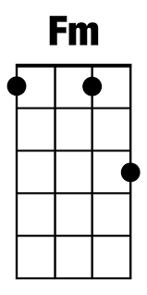
White Christmas

C F G
I'm dreaming of a white Christmas
F Dm ` C
Just like the ones I used to know
C C7
Where the treetops glisten
F Fm
And children listen
C F Dm G
To hear sleigh bells in the snow

C F G
I'm dreaming of a white Christmas
F Dm ` C
With every Christmas card I write
C C7 F Fm
May your days be merry and bright
C F Dm G
And may all your Christmases be white

