Your Cheatin’ Heart - in C

by Hank Williams

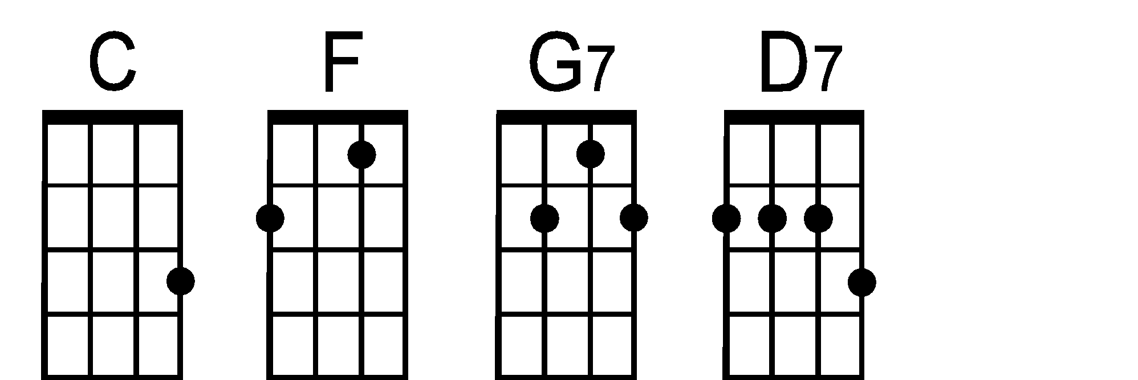

***Intro:*** C **. . .** |F **. . .** |G7 **. . .** |C **. . .** |

(sing g)

C\ (--*Tacet*--------) |C **. . .** | **. . . .** |F **. . .** |

Your cheat-in' heart will make you weep

**. . . .** |G7 **. . .** | **. . . .** |C **. . .** |

You'll cry and cry and try to sleep

C\ (--*Tacet*-----------) |C **. . .** | **. . . .** |F **. . .** |

But sleep won't come the whole night through

**. . . .** |G7 **. . .** | **. . . .** |C **. . .** |

Your cheat-in' heart will tell on you

***Chorus:*** C\ (--*Tacet*---------------) |F **. . .** | **. . . .** |C **. . .** |

When tears come down like fall-in' ra ain

**. . . .** |D7 **. . .** | **. . . .** |G7 **. . .** |

You'll toss a round and call my name

G7\ (--*Tacet*----------) |C **. . .** | **. . . .** |F **. . .** |

You'll walk the floor the way I do

**. . . .** |G7 **. . .** | **. . . .** |C **. . .** |

Your chea-tin' heart will tell on you

***Inst:*** C **. . .** | **. . . .** | **. . . .** |F **. . .** | **. . . .** |G7 **. . .** | **. . . .** |C **. . .** |

C\ (--*Tacet*--------) |C **. . .** | **. . . .** |F **. . .** |

Your cheatin' heart will pine some day

**. . . .** |G7 **. . .** | **. . . .** |C **. . .** |

and crave the love you threw a way

C\ (--*Tacet*-------) |C **. . .** | **. . . .** |F **. . .** |

The time will come when you'll be blue

**. . . .** |G7 **. . .** | **. . . .** |C **. . .** |

Your cheat-in' heart will tell on you

***Chorus:*** C\ (--*Tacet*---------------) |F **. . .** | **. . . .** |C **. . .** |

When tears come down like fall-in' ra ain

**. . . .** |D7 **. . .** | **. . . .** |G7 **. . .** |

You'll toss a round and call my name

G7\ (--*Tacet*----------) |C **. . .** | **. . . .** |F **. . .** |

You'll walk the floor the way I do

**. . . .** |G7 **. . .** | **. . . .** |C **. . .** | **.** G7\ **C\**

Your chea-tin' heart will tell on you

**San Jose Ukulele Club**

(v2-2/21/16)